*Text for website entry. 5-9-2025. Sandpiper Gallery: Pienaar van Niekerk*

***This work is on show with other entrants of the award at the Spier Arts Trust Gallery, Commercial Str, Cape Town till the 29th October 2025*.**

**South African Portrait Award 2025**

**Artist Statement**

I decided to enter the South African Portrait Award this year primarily because I saw it as an opportunity to comment on a human social issue.

The competition challenges artists to engage with a narrative which could imply social commentary.

Making use of portraiture as a medium, I saw it as an opportunity to make a strong statement about men, fathers who horrifically abuse daughters.

The portrait depicts a young daughter in a vulnerable situation, turning around and responding to some-one who has just entered the room. She says, as if expecting him: *Is that you, Daddy?*

She looks scared and has tears in her eyes, caught in a situation which is dangerous yet unavoidable. The emotional experience captured here is for both the subject and the viewer of the painting.

The bathroom is cold and uninviting, and the window, bath, tap, and towel provides information to the viewer of her situation. Her apparent nakedness makes her even more vulnerable. The warm flesh colours contrasted against the blue and darker background heighten to the drama.

***Oil on sized canvas***

***SIZE 69.5 X 59 cm***

***The Artwork is for sale***

***Contact Rust-en-Vrede Gallery for purchase***

<https://share.google/C2G3y91EA7XzH7DJR>

<https://rust-en-vrede.com/>

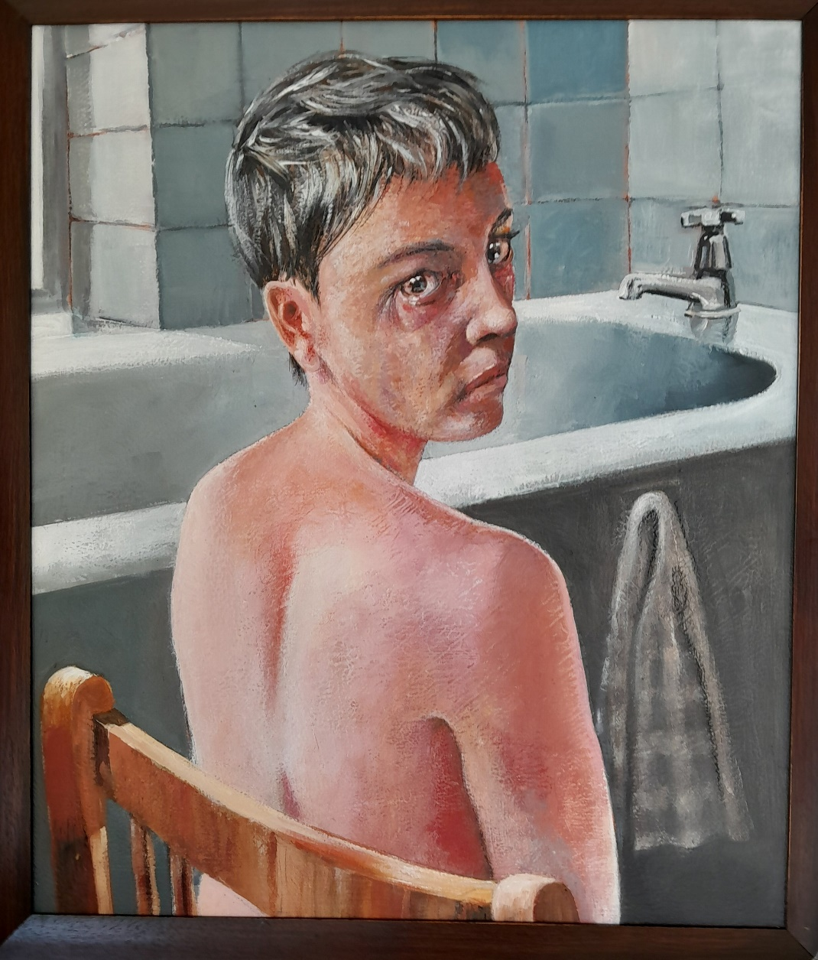Framed Painting. Oil on canvas.

**Pienaar van Niekerk.**

*Daddy is that you?*

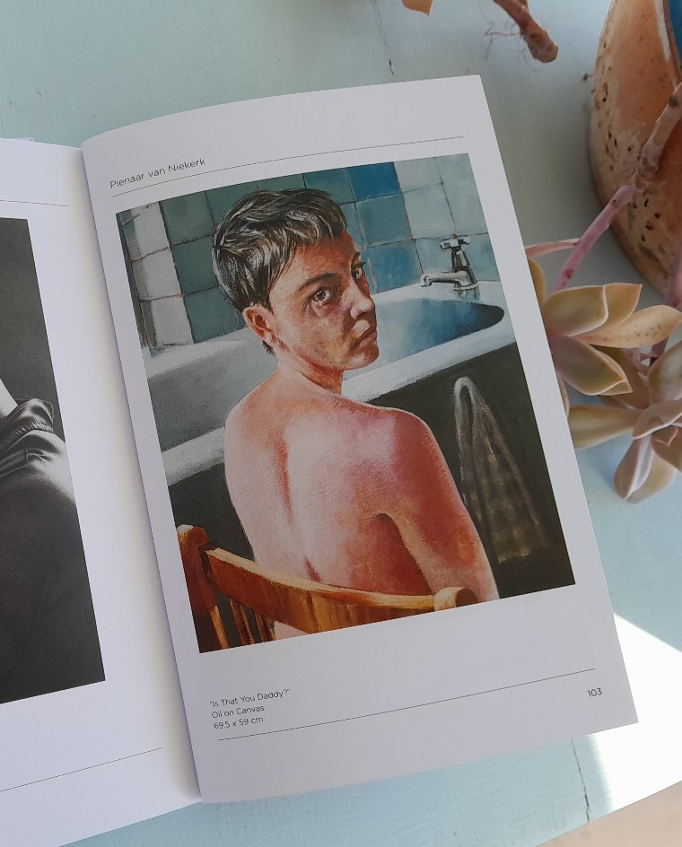 Catalogue Entry

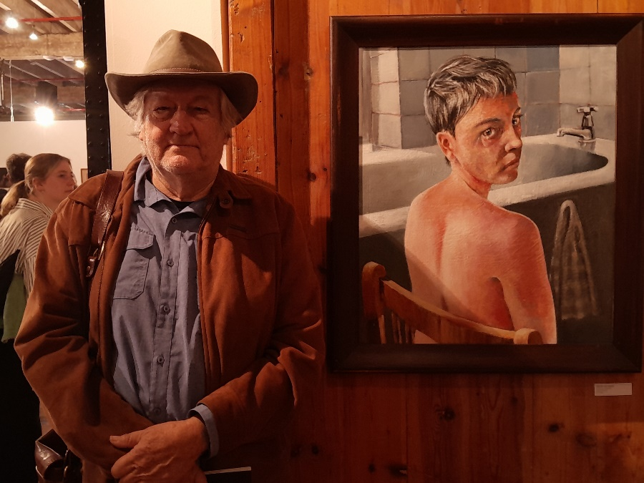

EExhee